

DATABASE

SPECIFICATIONS

Next-Gen Restaurant Application
Parv Bhatt (pnb5078@psu.edu)
Raghava Rao Sunkanapally (rxs6097@psu.edu)

School of Graduate Professional Studies
Information Science Department
IN SC 521 - Introduction to Database Concepts

October, 2021

Document Control

Work carried out by:
Name | Email Address | Other
Parv Bhatt | pnb5078@gmail.com
Raghava Rao Sunkanapally | rxs6097@gmail.com

Revision Sheet

Release No. | Date | Revision Description
1 | 10/31/2021 | Gathered the data requirements from a software specifications software
2 | 11/04/2021 | Updated the data requirements table as suggested by Dr. Barb
3 | 11/08/2021 | Built an ER Diagram and wrote about Assumptions/Constraints
4 | 11/15/2021 | Built a Logical Design of the ER Diagram
5 | 11/22/2021 | Performed Normalization on the tables
6 | 12/05/2021 | Implemented the physical design in SQL

DATABASE SPECIFICATIONS

TABLE OF CONTENTS

Document Control i
Work Carried out by i
Revision Sheet i

Milestone 1: Data Requirements 1
System Name or Title 1
Core Requirements 1

Milestone 2: Conceptual Design 3
ER Diagram 3
Assumptions & Constraints 4

Milestone 3: Logical Design 5
ER Diagram 5
Functional Dependencies 6
Assumptions & Constraints 10

Milestone 4: Normalization 11
Assumptions & Constraints 11
Tables 11

Milestone 5: Physical Design 11
Assumptions & Constraints 11
Tables 11

Milestone 6: SQL Queries 25

Milestone 1: Data Requirements

System Name or Title
Next – Gen Restaurant Application for Gotham City University

Core Requirements

No. | Requirement | Referenced page in SRS | Referenced Section in SRS | Referenced Paragraph in Section
DR1 | The database should store information about customers, like name, id, contact number, dob | 3  6  6  11 | 1.2  2.3  2.3  3.5 | 1  2  3  3.5.3.3 – 3.5.3.4
DR2 | The database should store information about orders. | 3 | 1.2 | Point 6
DR3 | The database should store information about table layout. | 3  5 | 1.2  2.2 | Point 1  Bullet 1
DR4 | The database should store party size, reservation time/date, table when assigned.  The database should also store the information about table occupancy and status. A waiting list number should also be maintained. | 5  5  12  12  10  11  11  8 | 2.1  2.2  3.5  3.6  3  3  3  3 | 2  Bullet 7  3.5.6  3.6.2  3.5.3.2  3.5.3.7  3.5.3.8  3.1.1
DR5 | The database should store the information about menu items and ingredients | 4  7 | 1.2  2.3 | Point 9  Table 1
DR6 | The database should store the information about staff details and scheduling. | 5 | 2.1 | 2
DR7 | The database should store the information about users’ roles, dob, authenticated usernames, and hashed password.  User’s roles include management members, servers, host/hostess, kitchen staff | 13  13  6  8  10 | 5.1  5.2  2.3  3  3 | 5.1.1  5.2.1  2  3.1.2  3.5.3.1
DR8 | The database should store the encrypted information about customers payment card details and bank account details. | 13  13 | 5.3  5.3 | 5.3.1  5.3.2
DR9 | The database should store the information about employee gratuities paid. | 9 | 3.5 | 3.5.1.5
DR10 | The database should store the information about customer payments from external third-party payment processing services and payment status | 8 | 2.5 | 2.5.1
DR11 | The database should store information about bar order/bar tab. | 10 | 3 | 3.5.1.10

Milestone 2: Conceptual Design

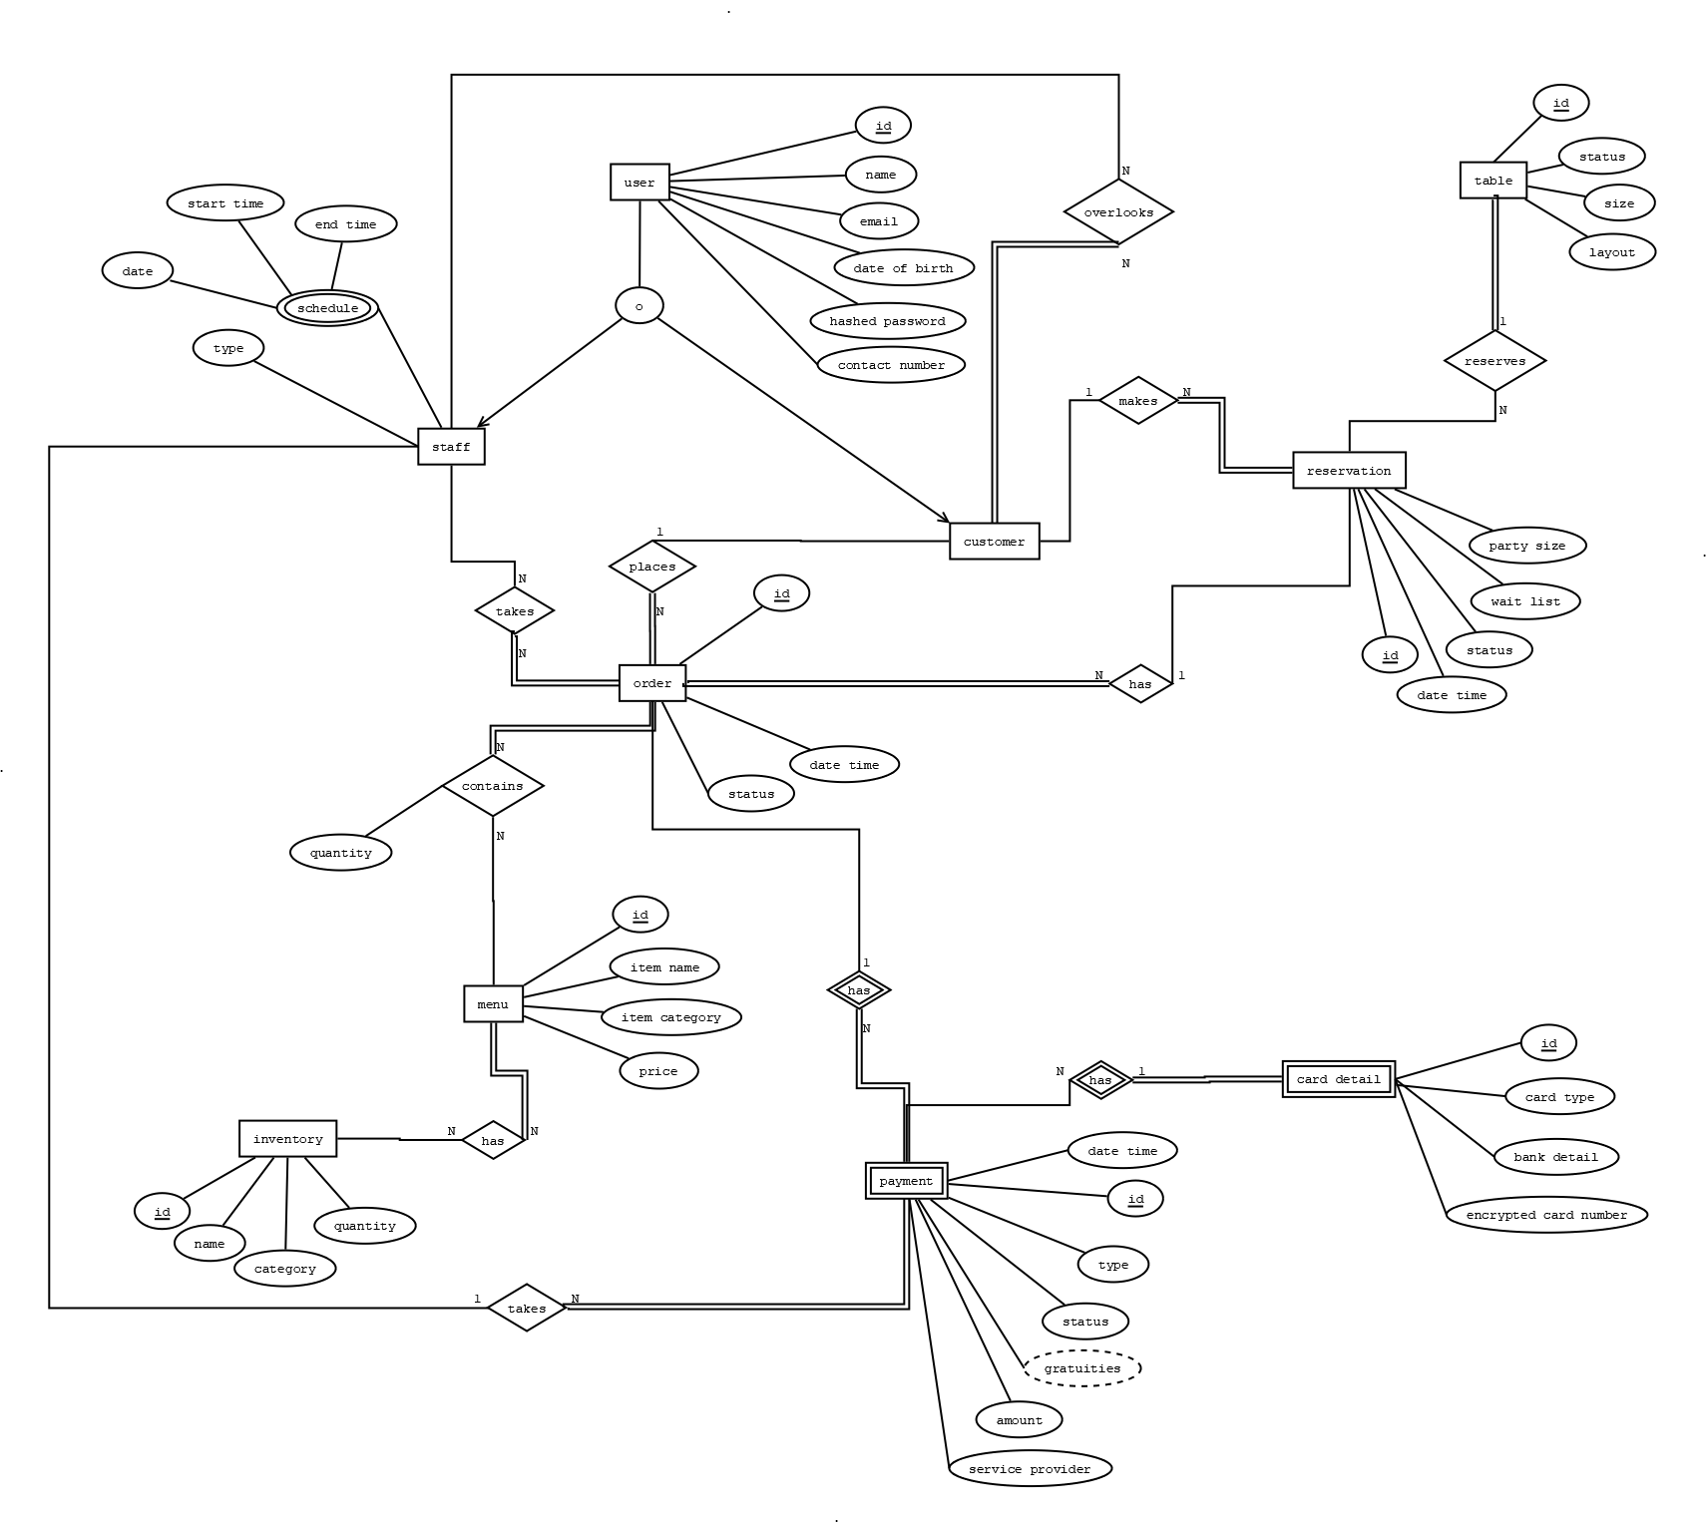
ER Diagram

Assumptions and Constraints

A: Customers visit this restaurant.
A: Customers can reserve their own table. If all tables are occupied, he/she will be added to the wait queue.
A: Staff member can be a customer also.
A: Each server (staff) takes order placed by the customer.
A: Kitchen staff manages the inventory.
A: A particular customer is managed by a single staff member.
A: The gratuities associated with a customer/order is linked to the corresponding staff member.
A: Payment stores total order amount and gratuities amount.
A: For each non-cash payment done by customer, encrypted card detail is stored.
A: Each card detail is identified using weak entity; set "card details" discriminator key id.
C: Menu will have only those items which can be prepared from the current inventory.
C: Alcoholic beverage will only be served to customers whose age is greater than 21 years.
C: Alcoholic beverage will be served only by staff whose age is more than 21 years.

Milestone 3: Logical Design

Entity Relationship Diagram
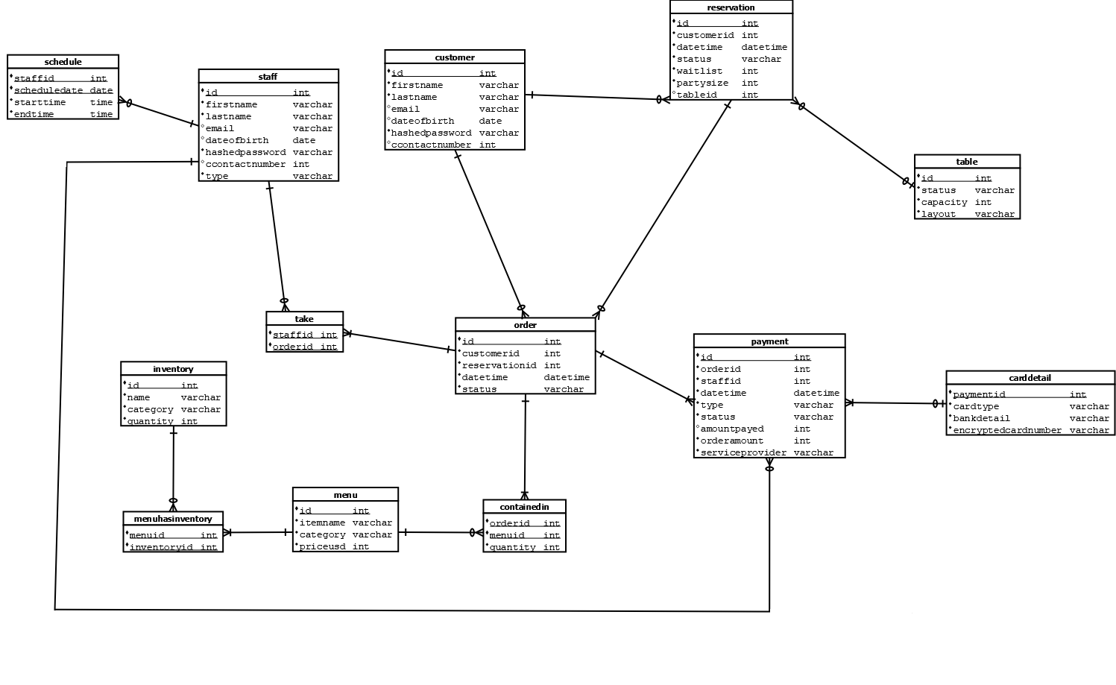

Entity name: staff
Attributes:
id, firstname, lastname, email, dateofbirth, hashedpassword, contactnumber, type, schedule
Functional dependencies:
id → firstname, lastname, email, dateofbirth, hashedpassword, contactnumber, type, schedule
Attributes not in FD | Attributes on the left | Attributes on both sides | Attributes on the right side
 | id |  | firstname, lastname, email, dateofbirth, hashedpassword, type, schedule, contactnumber

Attribute closures (if any):
id+ = firstname, lastname, email, dateofbirth, hashedpassword, contactnumber, type, schedule
Unique keys: the key for this table is/are
id

Entity name: customer
Attributes:
id, firstname, lastname, email, dateofbirth, hashedpassword, contactnumber
Functional dependencies:
id → firstname, lastname, email, dateofbirth, hashedpassword, contactnumber

Attributes not in FD | Attributes on the left | Attributes on both sides | Attributes on the right side
 | id |  | firstname, lastname, email, dateofbirth, hashedpassword, contactnumber

Attribute closures (if any):
id+ = firstname, lastname, email, dateofbirth, hashedpassword, contactnumber

Unique keys: the key for this table is/are
id

Entity name: reservation
Attributes:
id, customerid, datetime, status, waitlist, partysize, tableid
Functional dependencies:
id → datetime, status, waitlist, partysize
customerid → customer
tableid → table

Attributes not in FD | Attributes on the left | Attributes on both sides | Attributes on the right side
 | id |  | datetime, status, waitlist, partysize
 | customerid |  | customer
 | tableid |  | table

Attribute closures (if any):
id+ = customerid, tableid, datetime, status, waitlist, partysize
customerid+ = customer
tableid+ = table

Unique keys: the key for this table is/are
id

Entity name: table
Attributes:
id, status, capacity, layout
Functional dependencies:
id → status, capacity, layout
Attributes not in FD | Attributes on the left | Attributes on both sides | Attributes on the right side
 | id |  | status, capacity, layout

Attribute closures (if any):
id+ = status, capacity, layout
Unique keys: the key for this table is/are
id

Entity name: order
Attributes:
id, status, customerid, datetime, reservationid
Functional dependencies:
id → status, datetime, customerid, reservationid
customerid → customer
reservationid → reservation
Attributes not in FD | Attributes on the left | Attributes on both sides | Attributes on the right side
 | id |  | status, datetime
 | customerid |  | customer
 | reservationid |  | reservationid

Attribute closures (if any):
id+ = status, datetime
customerid+ = customer
reservationid+ = reservation

Unique keys: the key for this table is/are
id
Entity name: payment
Attributes:
id, orderid, staffid, datetime, type, status, amountpaid, orderamount, serviceprovider
Functional dependencies:
id → datetime, type, status, amountpaid, orderamount, serviceprovider, orderid, staffid
orderid → order
staffid → staff
Attributes not in FD | Attributes on the left | Attributes on both sides | Attributes on the right side
 | id |  | datetime, type, status, amountpaid, orderamount, serviceprovider
 | orderid |  | order
 | staffid |  | staff

Attribute closures (if any):
id+ = status, datetime, type, amountpaid, orderamount, serviceprovider, orderid, staffid
orderid+ = order
staffid+ = staff
Unique keys: the key for this table is/are
id

Entity name: carddetail
Attributes:
paymentid, cardtype. bankdetail, encryptedcardnumber
Functional dependencies:
paymentid → payment, cardtype. bankdetail, encryptedcardnumber

Attributes not in FD | Attributes on the left | Attributes on both sides | Attributes on the right side
 | paymentid |  | payment, cardtype. bankdetail, encryptedcardnumber
Attribute closures (if any):
paymentid+ = payment, cardtype, bankdetail, encryptedcardnumber

Unique keys: the key for this table is/are
paymentid

Entity name: menu
Attributes:
id, itemname, category, priceusd, quantity, orderid
Functional dependencies:
id → itemname, category, priceusd

Attributes not in FD | Attributes on the left | Attributes on both sides | Attributes on the right side
 | id |  | itemname, category, priceusd

Attribute closures (if any):
id+ = itemname, category, priceusd

Unique keys: the key for this table is/are
id
Entity name: inventory
Attributes:
id, name, category, quantity, menuid
Functional dependencies:
id → name, category, quantity

Attributes not in FD | Attributes on the left | Attributes on both sides | Attributes on the right side
 | id |  | name, category, quantity

Attribute closures (if any):
id+ = name, category, quantity

Unique keys: the key for this table is/are
id

Assumptions and Constraints
A: Customers visit this restaurant.
A: Customers can reserve their own table. If all tables are occupied, he/she will be added to the wait queue.
A: Staff member can be a customer also.
A: Each server (staff) takes order placed by the customer.
A: Kitchen staff manages the inventory.
A: A particular customer is managed by a single staff member.
A: The gratuities associated with a customer/order is linked to the corresponding staff member.
A: Payment stores total order amount and gratuities amount.
A: For each non-cash payment done by customer, encrypted card detail is stored.
A: Each card detail is identified using weak entity; set "card details" discriminator key id.
C: Menu will have only those items which can be prepared from the current inventory.
C: Alcoholic beverage will only be served to customers whose age is greater than 21 years.
C: Alcoholic beverage will be served only by staff whose age is more than 21 years.

Milestone 4: Normalization and

Milestone 5: Physical Design

Assumptions and Constraints

A: Customers visit this restaurant.
A: Customers can reserve their own table. If all tables are occupied, he/she will be added to the wait queue.
A: Staff member can be a customer also.
A: Each server (staff) takes order placed by the customer.
A: Kitchen staff manages the inventory.
A: A particular customer is managed by a single staff member.
A: The gratuities associated with a customer/order is linked to the corresponding staff member.
A: Payment stores total order amount and gratuities amount.
A: For each non-cash payment done by customer, encrypted card detail is stored.
A: Each card detail is identified using weak entity; set "card details" discriminator key id.
C: Menu will have only those items which can be prepared from the current inventory.
C: Alcoholic beverage will only be served to customers whose age is greater than 21 years.
C: Alcoholic beverage will be served only by staff whose age is more than 21 years.

Tables

 | Name of the table | customer
 | Description | a customer is a person that visits the restaurant.
 | Attribute | Description |  | Type | Examples of values | Notes
 | id | ID of a customer |  | number | 12345 | Unique, Not Null
 | firstname | First name of the customer |  | varchar | Raghava | Not Null
 | lastname | Last name of the customer |  | varchar | Sunkanapally | Can be null
 | email | Email of the customer |  | varchar | abc@gmail.com | Unique, Can be Null
 | dateofbirth | Date of Birth of the customer |  | date | 01/01/1995 | Can be Null
 | hashedpassword | Encrypted hashed password for customer login |  | varchar | ABC123@# | Not Null
 | contactnumber | Contact Number of the customer |  | number | 9999999999 | Unique, Can be Null
 | Functional Dependencies and Keys
 | Functional dependencies | id → firstname, lastname, email, dateofbirth, hashedpassword, contactnumber
 | Candidate keys | id
 | Normalization
 | 1NF | Yes | All cells contain a unique value
 | 2NF | Yes | Table is in 1NF and no prime attribute is dependent on any proper  subset of any candidate key of the table
 | 3NF | Yes | All the non-key attributes depend only on a key
 | BCNF | Yes | Every functional dependency X → Y, X is the super key of the table
 | Physical Design
 | Primary Key | id
 | Foreign Keys | -
 | SQL Code | CREATE TABLE customer  (  id NUMBER(10) PRIMARY KEY,  firstname VARCHAR2(50) NOT NULL,  lastname VARCHAR2(50),  email VARCHAR2(255) UNIQUE,  dateofbirth DATE,  hashedpassword VARCHAR2(255) NOT NULL,  contactnumber NUMBER(20) UNIQUE  );
 | Count of records in the table | 50

...

 | Name of the table | staff
 | Description | a staff is a person that works for our restaurant. There are many types of staff: Chef, Waiter, Management, Owner, etc.
 | Attribute | Description |  | Type | Examples of values | Notes
 | id | ID of a staff |  | number | 123 | Unique, Not Null
 | firstname | First Name of Staff |  | varchar | Parv | Not Null
 | lastname | Last Name of Staff |  | varchar | Bhatt | Not Null
 | email | Email of Staff |  | varchar | abc@gmail.com | Unique, Not null
 | dateofbirth | date of birth of staff |  | date | 01/01/1997 | Not Null
 | hashedpassword | hashed passwords of the staff |  | varchar | abcdefgh | Not Null
 | contactnumber | Contact number of a staff member |  | number | 9999999999 | Not Null
 | type | Designation of the staff |  | varchar | host, server, chef | Not Null
 | Functional Dependencies and Keys
 | Functional dependencies | id → firstname, lastname, email, dateofbirth, hashedpassword, contactnumber, type
 | Candidate keys | id
 | Normalization
 | 1NF | Yes | All cells contain a unique value
 | 2NF | Yes | Table is in 1NF and no prime attribute is dependent on any proper  subset of any candidate key of the table
 | 3NF | Yes | All the non-key attributes depend only on a key
 | BCNF | Yes | Every functional dependency X → Y, X is the super key of the table
 | Physical Design
 | Primary Key | id
 | Foreign Keys | -
 | SQL Code | CREATE TABLE staff  (  id NUMBER(10) PRIMARY KEY,  firstname VARCHAR2(50) NOT NULL,  lastname VARCHAR2(50) NOT NULL,  email VARCHAR2(255) UNIQUE NOT NULL,  dateofbirth DATE NOT NULL,  hashedpassword VARCHAR2(255) NOT NULL,  contactnumber NUMBER(20) UNIQUE NOT NULL,  type VARCHAR2(50) NOT NULL  );
 | Count of records in the table | 20

...

 | Name of the table | schedule
 | Description | Stores the daily schedule of each staff member.
 | Attribute | Description |  | Type | Examples of values | Notes
 | staffid | Id of the staff |  | number | 1235 | Not Null
 | scheduledate | Date of the schedule |  | date | 09/21/2021 | Not Null
 | starttime | Start time of the staff schedule |  | time | 14:00 | Not Null
 | endtime | End time of the staff schedule |  | time | 21:00 | Not Null
 | Functional Dependencies and Keys
 | Functional dependencies | (staffid, scheduledate) → starttime, endtime
 | Candidate keys | (staffid, scheduledate)
 | Normalization
 | 1NF | Yes | All cells contain a unique value
 | 2NF | Yes | Table is in 1NF and no prime attribute is dependent on any proper  subset of any candidate key of the table
 | 3NF | Yes | All the non-key attributes depend only on a key
 | BCNF | Yes | Every functional dependency X → Y, X is the super key of the table
 | Physical Design
 | Primary Key | (staffid, scheduledate)
 | Foreign Keys | staffid
 | SQL Code | CREATE TABLE schedule  (  staffid NUMBER(10) NOT NULL,  scheduledate DATE NOT NULL,  starttime TIMESTAMP WITH LOCAL TIME ZONE NOT NULL,  endtime TIMESTAMP WITH LOCAL TIME ZONE NOT NULL,  CONSTRAINT pk_schedule_id PRIMARY KEY (staffid,scheduledate),  CONSTRAINT fk_staff_id FOREIGN KEY(staffid) REFERENCES staff(id)  );
 | Count of records in the table | 23

...

 | Name of the table | reservation
 | Description | Stores the reservation details of the customers.
 | Attribute | Description |  | Type | Examples of values | Notes
 | id | Id of the reservation table |  | number | 123456 | Unique, Not null
 | customerid | Id of the customer made the reservation |  | number | 345 | Not null
 | datetime | time stamp of the reservation attempted |  | datetime | 09-21-2019 14:30:00 | Not null
 | status | Status of the reservation |  | varchar | success, waitlist, failed | Not null
 | waitlist | waitlist number in the reservation queue |  | number | 2 | Can be Null
 | partysize | Resevation made for number of people |  | number | 4 | Can be Null (If Status =Failed)
 | tableid | Id of the table reserved |  | number | 1 | Can be Null (If Status =Failed, waitlist)
 | Functional Dependencies and Keys
 | Functional dependencies | id → customerid, datetime, status, waitlist, partysize, tableid
 | Candidate keys | id
 | Normalization
 | 1NF | Yes | All cells contain a unique value
 | 2NF | Yes | Table is in 1NF and no prime attribute is dependent on any proper  subset of any candidate key of the table
 | 3NF | Yes | All the non-key attributes depend only on a key
 | BCNF | Yes | Every functional dependency X → Y, X is the super key of the table
 | Physical Design
 | Primary Key | id
 | Foreign Keys | customerid, tableid
 | SQL Code | CREATE TABLE reservation  (  id NUMBER(10) PRIMARY KEY,  customerid NUMBER(10) NOT NULL,  datetime TIMESTAMP WITH LOCAL TIME ZONE NOT NULL,  status VARCHAR2(50) NOT NULL,  waitlist NUMBER(2),  partysize NUMBER(2),  tableid NUMBER(2),  CONSTRAINT fk_reservecust_id FOREIGN KEY(customerid) REFERENCES customer(id),  CONSTRAINT fk_reservetable_id FOREIGN KEY(tableid) REFERENCES tble(id)  );
 | Count of records in the table | 50

...

 | Name of the table | tble
 | Description | Table details in the restaurant.
 | Attribute | Description |  | Type | Examples of values | Notes
 | id | Id of the table |  | number | 1 | Unique, Not null
 | status | Status of the table |  | varchar | Occupied, Empty | Not Null
 | capacity | Table capacity |  | number | 4 | Not Null
 | layout | Layout of the table |  | varchar | corner | Not Null
 | Functional Dependencies and Keys
 | Functional dependencies | id → status, capacity, layout
 | Candidate keys | id
 | Normalization
 | 1NF | Yes | All cells contain a unique value
 | 2NF | Yes | Table is in 1NF and no prime attribute is dependent on any proper  subset of any candidate key of the table
 | 3NF | Yes | All the non-key attributes depend only on a key
 | BCNF | Yes | Every functional dependency X → Y, X is the super key of the table
 | Physical Design
 | Primary Key | id
 | Foreign Keys | -
 | SQL Code | CREATE TABLE tble  (  id NUMBER(10) PRIMARY KEY,  status VARCHAR2(50) NOT NULL,  capacity NUMBER(2) NOT NULL,  layout VARCHAR2(50) NOT NULL  );
 | Count of records in the table | 10

...

 | Name of the table | orders
 | Description | Details of the order placed by the customer.
 | Attribute | Description |  | Type | Examples of values | Notes
 | id | Id of the order |  | number | 234 | Unique, Not Null
 | customerid | Id of the customer placed. |  | number | 456 | Not Null
 | reservationid | Id of the reservation. |  | number | 678 | Not Null
 | datetime | Time stamp when the order is placed. |  | datetime | 09-21-2019 14:30:00 | Not Null
 | status | Status of the order |  | varchar | Served, Inprogress, cancelled | Not Null
 | Functional Dependencies and Keys
 | Functional dependencies | id → customerid, reservationid, datetime, status
 | Candidate keys | id
 | Normalization
 | 1NF | Yes | All cells contain a unique value
 | 2NF | Yes | Table is in 1NF and no prime attribute is dependent on any proper  subset of any candidate key of the table
 | 3NF | Yes | All the non-key attributes depend only on a key
 | BCNF | Yes | Every functional dependency X → Y, X is the super key of the table
 | Physical Design
 | Primary Key | id
 | Foreign Keys | customerid, reservationid
 | SQL Code | CREATE TABLE orders  (  id NUMBER(10) PRIMARY KEY,  customerid NUMBER(10) NOT NULL,  reservationid NUMBER(10) NOT NULL,  datetime TIMESTAMP WITH LOCAL TIME ZONE NOT NULL,  status VARCHAR2(50) NOT NULL,  CONSTRAINT fk_ordercust_id FOREIGN KEY(customerid) REFERENCES customer(id),  CONSTRAINT fk_orderreserve_id FOREIGN KEY(reservationid) REFERENCES reservation(id)  );
 | Count of records in the table | 20

...

 | Name of the table | take
 | Description | Stores the staff id for each order.
 | Attribute | Description |  | Type | Examples of values | Notes
 | staffid | Id of the staff |  | number | 123 | Not Null
 | orderid | Id of the order |  | number | 456 | Not Null
 | Functional Dependencies and Keys
 | Functional dependencies
 | Candidate keys | (staffid, orderid)
 | Normalization
 | 1NF | Yes | All cells contain a unique value
 | 2NF | Yes | Table is in 1NF and no prime attribute is dependent on any proper  subset of any candidate key of the table
 | 3NF | Yes | All the non-key attributes depend only on a key
 | BCNF | Yes | Every functional dependency X → Y, X is the super key of the table
 | Physical Design
 | Primary Key | (staffid, orderid)
 | Foreign Keys | staffid, orderid
 | SQL Code | CREATE TABLE take  (  staffid NUMBER(10) NOT NULL,  orderid NUMBER(10) NOT NULL,  CONSTRAINT pk_take_id PRIMARY KEY (staffid,orderid),  CONSTRAINT fk_takestaff_id FOREIGN KEY(staffid) REFERENCES staff(id),  CONSTRAINT fk_takeorder_id FOREIGN KEY(orderid) REFERENCES orders(id)  );
 | Count of records in the table | 20

...

 | Name of the table | containedin
 | Description | Stores the menu id and quantity for each order
 | Attribute | Description |  | Type | Examples of values | Notes
 | orderid | Id of the customer |  | number | 123 | Not Null
 | menuid | Id of the menu |  | number | 156 | Not Null
 | quantity | Quantity of the menu items ordered |  | number | 3 | Not Null
 | Functional Dependencies and Keys
 | Functional dependencies | (orderid, menuid) → quantity
 | Candidate keys | (orderid, menuid)
 | Normalization
 | 1NF | Yes | All cells contain a unique value
 | 2NF | Yes | Table is in 1NF and no prime attribute is dependent on any proper  subset of any candidate key of the table
 | 3NF | Yes | All the non-key attributes depend only on a key
 | BCNF | Yes | Every functional dependency X → Y, X is the super key of the table
 | Physical Design
 | Primary Key | (menuid, orderid)
 | Foreign Keys | menuid, orderid
 | SQL Code | CREATE TABLE containedin  (  menuid NUMBER(10) NOT NULL,  orderid NUMBER(10) NOT NULL,  quantity NUMBER(10) NOT NULL,  CONSTRAINT pk_containedin_id PRIMARY KEY (menuid,orderid),  CONSTRAINT fk_containedinstaff_id FOREIGN KEY(menuid) REFERENCES menu(id),  CONSTRAINT fk_containedinorder_id FOREIGN KEY(orderid) REFERENCES orders(id)  );
 | Count of records in the table | 43

...

 | Name of the table | menu
 | Description | Stores the menu details served in the restaurant.
 | Attribute | Description |  | Type | Examples of values | Notes
 | id | Id of the menu |  | number | 56897 | Unique, Not null
 | itemname | Name of the item |  | varchar | Coffee | Not Null
 | categories | Category of the item |  | varchar | Beverages | Not Null
 | priceusd | Price of the item |  | float | 9.99 | Not Null
 | Functional Dependencies and Keys
 | Functional dependencies | id → itemname, categories, priceusd
 | Candidate keys | id
 | Normalization
 | 1NF | Yes | All cells contain a unique value
 | 2NF | Yes | Table is in 1NF and no prime attribute is dependent on any proper  subset of any candidate key of the table
 | 3NF | Yes | All the non-key attributes depend only on a key
 | BCNF | Yes | Every functional dependency X → Y, X is the super key of the table
 | Physical Design
 | Primary Key | id
 | Foreign Keys | -
 | SQL Code | CREATE TABLE menu  (  id NUMBER(10) PRIMARY KEY,  itenname VARCHAR2(50) NOT NULL,  categories VARCHAR2(50) NOT NULL,  priceusd FLOAT(5) NOT NULL  );
 | Count of records in the table | 11

...

 | Name of the table | inventory
 | Description | Stores inventory of the items.
 | Attribute | Description |  | Type | Examples of values | Notes
 | id | Id of the inventory |  | number | 67595 | Unique, Not Null
 | name | Name of the inventory |  | varchar | Coffee beans | Not Null
 | category | Category |  | varchar | Beans | Not Null
 | quantity | Quantity left in the inventory. |  | number | 3 | Not Null
 | Functional Dependencies and Keys
 | Functional dependencies | id → name, category, quantity
 | Candidate keys | id
 | Normalization
 | 1NF | Yes | All cells contain a unique value
 | 2NF | Yes | Table is in 1NF and no prime attribute is dependent on any proper  subset of any candidate key of the table
 | 3NF | Yes | All the non-key attributes depend only on a key
 | BCNF | Yes | Every functional dependency X → Y, X is the super key of the table
 | Physical Design
 | Primary Key | id
 | Foreign Keys | -
 | SQL Code | CREATE TABLE inventory  (  id NUMBER(10) PRIMARY KEY,  name VARCHAR2(50) NOT NULL,  categories VARCHAR2(50) NOT NULL,  quantity NUMBER(10) NOT NULL  );
 | Count of records in the table | 14

...

 | Name of the table | menuhasinventory
 | Description | Stores the inventory items for each menu item.
 | Attribute | Description |  | Type | Examples of values | Notes
 | menuid | Id of the menu item |  | number | 3453 | Not Null
 | inventoryid | Id of the inventory item |  | number | 5676 | Not Null
 | Functional Dependencies and Keys
 | Functional dependencies
 | Candidate keys | (menuid, inventoryid)
 | Normalization
 | 1NF | Yes | All cells contain a unique value
 | 2NF | Yes | Table is in 1NF and no prime attribute is dependent on any proper  subset of any candidate key of the table
 | 3NF | Yes | All the non-key attributes depend only on a key
 | BCNF | Yes | Every functional dependency X → Y, X is the super key of the table
 | Physical Design
 | Primary Key | (menuid, inventoryid)
 | Foreign Keys | menuid, inventoryid
 | SQL Code | CREATE TABLE menuhasinventory  (  menuid NUMBER(10) NOT NULL,  inventoryid NUMBER(10) NOT NULL,  CONSTRAINT pk_menuhasinventory_id PRIMARY KEY (menuid,inventoryid),  CONSTRAINT fk_menuhasinventorymenu_id FOREIGN KEY(menuid) REFERENCES menu(id),  CONSTRAINT fk_menuhasinventoryinventory_id FOREIGN KEY(inventoryid) REFERENCES inventory(id)  );
 | Count of records in the table | 31

...

 | Name of the table | payment
 | Description | Stores the payment details attempted by the customer.
 | Attribute | Description |  | Type | Examples of values | Notes
 | id | Id of the payment |  | number | 76853 | Unique, Not Null
 | orderid | Id of the order |  | number | 5646 | Not Null
 | staffid | Id of the staff |  | number | 76854 | Not Null
 | datetime | Time stamp when payment is attempted |  | datetime | 09-21-2019 14:30:00 | Not Null
 | type | Mode of the payment by the customer |  | varchar | Cash, Credit Card | Not Null
 | status | Status of the payment |  | varchar | Success, Processing, Failed | Not Null
 | amountpaid | Amount paid by the customer |  | float | 45 | Not null
 | orderamount | Amount of the Order |  | float | 40 | Not Null
 | serviceprovider | Third Party Service partner of the payment |  | varchar | easypay | Can be null (Type=Cash)
 | Functional Dependencies and Keys
 | Functional dependencies | id → orderid, staffid, datetime, type, status, amountpaid, orderamount, serviceprovider
 | Candidate keys | id
 | Normalization
 | 1NF | Yes | All cells contain a unique value
 | 2NF | Yes | Table is in 1NF and no prime attribute is dependent on any proper  subset of any candidate key of the table
 | 3NF | Yes | All the non-key attributes depend only on a key
 | BCNF | Yes | Every functional dependency X → Y, X is the super key of the table
 | Physical Design
 | Primary Key | id
 | Foreign Keys | orderid, staffid
 | SQL Code | CREATE TABLE payment  (  id NUMBER(10) PRIMARY KEY,  orderid NUMBER(10) NOT NULL,  staffid NUMBER(10) NOT NULL,  datetime TIMESTAMP WITH LOCAL TIME ZONE NOT NULL,  type VARCHAR2(50) NOT NULL,  status VARCHAR2(50) NOT NULL,  amountpaid FLOAT(5) NOT NULL,  orderamount FLOAT(5) NOT NULL,  serviceprovider VARCHAR2(50),  CONSTRAINT fk_paymentorder_id FOREIGN KEY(orderid) REFERENCES orders(id),  CONSTRAINT fk_paymentstaff_id FOREIGN KEY(staffid) REFERENCES staff(id)  );
 | Count of records in the table | 9

...

 | Name of the table | carddetail
 | Description | Stores the card details for payment made by the non-cash type.
 | Attribute | Description |  | Type | Examples of values | Notes
 | paymentid | Id of the payment |  | number | 684567 | Unique, Not Null
 | cardtype | Type of the Card |  | varchar | Credit, debit | Not Null
 | bankdetail | Name of the bank |  | varchar | PNC | Can be null
 | encryptedcardnumber | encrypted card number |  | varchar | xxxxxxxxxx7868 | Not Null
 | Functional Dependencies and Keys
 | Functional dependencies | paymentid → cardtype, bankdetail, encryptedcardnumber
 | Candidate keys | paymentid
 | Normalization
 | 1NF | Yes | All cells contain a unique value
 | 2NF | Yes | Table is in 1NF and no prime attribute is dependent on any proper  subset of any candidate key of the table
 | 3NF | Yes | All the non-key attributes depend only on a key
 | BCNF | Yes | Every functional dependency X → Y, X is the super key of the table
 | Physical Design
 | Primary Key | paymentid
 | Foreign Keys | paymentid
 | SQL Code | CREATE TABLE carddetail  (  paymentid NUMBER(10) NOT NULL UNIQUE,  cardtype VARCHAR2(50) NOT NULL,  bankdetail VARCHAR2(50),  encryptedcardnumber VARCHAR2(255) NOT NULL,  CONSTRAINT fk_carddetailpayment_id FOREIGN KEY(paymentid) REFERENCES payment(id)  );
 | Count of records in the table | 6

Milestone 6: SQL queries

Query 1
English version | DISPLAY ALL THE name of CUSTOMERS TO WHOM YOU CAN SEND TEXT EMAIL
SQL sentence | SELECT concat(concat(firstname, ' '), lastname) as Customer_Name, email FROM customer WHERE email IS NOT NULL ;
Example of returned rows (cropped screen caption) | 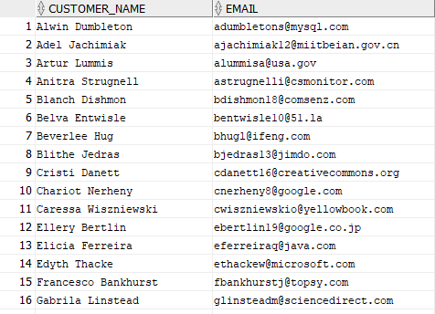

…

Query 2
English version | Display all the name of customers whose order is more than $75
SQL sentence | SELECT concat(concat(c.firstname, ' '), c.lastname) as Customer_Name, p.orderamount  FROM payment p  INNER JOIN orders o ON p.orderid = o.id AND p.orderamount > 75  INNER JOIN customer c on o.customerid = c.id;
Example of returned rows (cropped screen caption) | 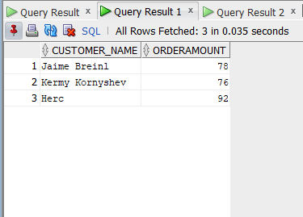

…

Query 3
English version | Display the orderid, name of customers, and count of items where the cusomter orders more than 2 items
SQL sentence | SELECT co.orderid, concat(concat(c.firstname, ' '), c.lastname) as Customer_Name, COUNT(co.menuid) as Count_of_Items  FROM orders o  INNER JOIN containedin co ON o.id = co.orderid  INNER JOIN customer c ON c.id = o.customerid  GROUP BY co.orderid, c.firstname, c.lastname  HAVING COUNT(co.menuid) > 2;
Example of returned rows (cropped screen caption) | 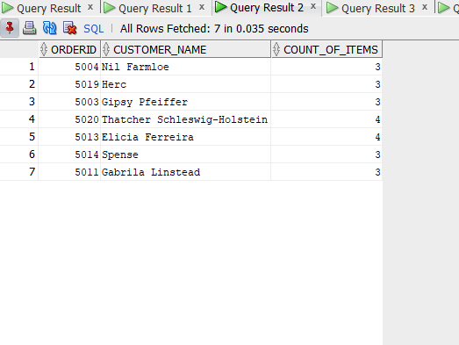

…

Query 4
English version | Display the names of staff whose first name ends with 'L' and has received gratituity greater than $100
SQL sentence | SELECT DISTINCT concat(concat(s.firstname, ' '), s.lastname) as Staff_Name, SUM(p.amountpaid - p.orderamount) as gratituity  FROM payment p  INNER JOIN staff s ON s.id = p.staffid  WHERE s.firstname LIKE '%l' AND (p.amountpaid - p.orderamount) > 50  GROUP BY s.firstname, s.lastname;
Example of returned rows (cropped screen caption) | 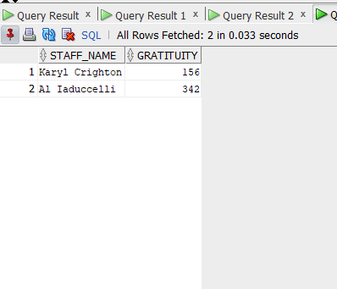

…

Query 5
English version | Display the names and age of staff who took alcohol orders (age should be greater than 21)
SQL sentence | SELECT DISTINCT concat(concat(s.firstname, ' '), s.lastname) as Staff_Name, TRUNC((SYSDATE - TO_DATE(s.dateofbirth, 'DD-MON-YYYY'))/ 365) AS AGE  FROM orders o  LEFT JOIN take t on t.orderid = o.id  LEFT JOIN staff s on s.id = t.staffid  INNER JOIN containedin co on co.orderid = o.id  INNER JOIN menu m on m.id = co.menuid AND m.categories = 'alcoholic beverages';
Example of returned rows (cropped screen caption) | 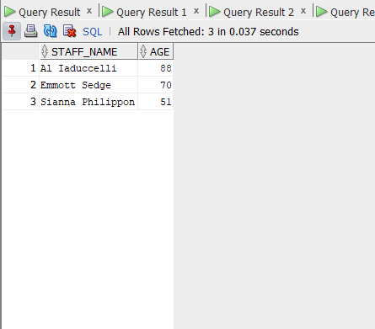

…

Query 6
English version | Display the names of the customer who got center tables
SQL sentence | SELECT concat(concat(c.firstname, ' '), c.lastname) as Customer_Name  FROM reservation r  INNER JOIN customer c ON c.id = r.customerid  WHERE r.status = 'success' AND r.tableid IN (SELECT t.id FROM tble t WHERE t.layout = 'center');
Example of returned rows (cropped screen caption) | 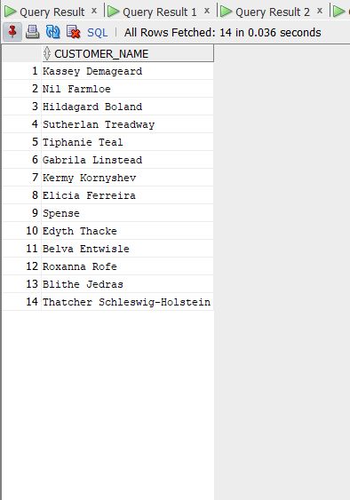

…

Query 7
English version | Display the customer name whose order is in progess
SQL sentence | SELECT (SELECT concat(concat(c.firstname, ' '), c.lastname) FROM customer c WHERE customerid = id) as Customer_Name, o.status  FROM orders o WHERE o.status = 'in progress';
Example of returned rows (cropped screen caption) | 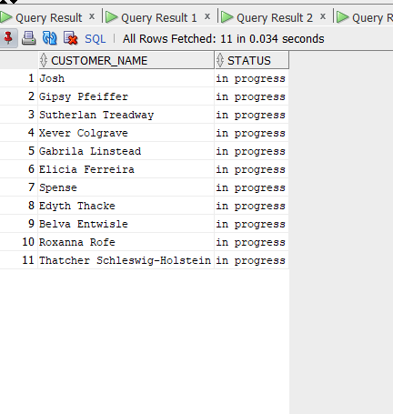

…

Query 8
English version | Labelling name and id of staff based on the number of orders taken
SQL sentence | SELECT s.id, concat(concat(s.firstname, ' '), s.lastname) as Staff_Name, CASE WHEN count(*) > 3 THEN 'HARD-WORKING' WHEN count(*) BETWEEN 1 AND 2 THEN 'AVERAGE' ELSE 'LAZY' END as Staff_Label  FROM take t  INNER JOIN staff s on s.id = t.staffid  GROUP BY s.id,s.firstname, s.lastname;
Example of returned rows (cropped screen caption) | 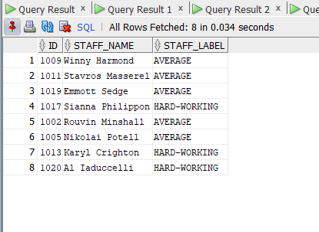

…

Query 9
English version | Display the names of the staff who took have pending orders and verified the card payments done by visa cards
SQL sentence | SELECT DISTINCT concat(concat(s.firstname, ' '), s.lastname) as Staff_Name, s.dateofbirth  FROM staff s, payment p, orders o, carddetail cd  WHERE s.id=p.staffid AND o.id=p.orderid AND cd.cardtype = 'visa'  UNION  SELECT DISTINCT concat(concat(s.firstname, ' '), s.lastname) as Staff_Name, s.dateofbirth  FROM staff s, payment p, orders o  WHERE s.id=p.staffid AND o.id=p.orderid AND o.status = 'in progress';
Example of returned rows (cropped screen caption) | 



